MUHAMMAD WAMIQ AKRAM(20k-1857)

COAL LAB : 3

QUESTION 1:

TITLE My First Program (Test.asm)

INCLUDE Irvine32.inc

.data

val1 SWORD ?

val2 SBYTE -10

.code

main PROC

mov eax, 0

mov al, val2

mov bx , val1

call DumpRegs

exit

main ENDP

END main

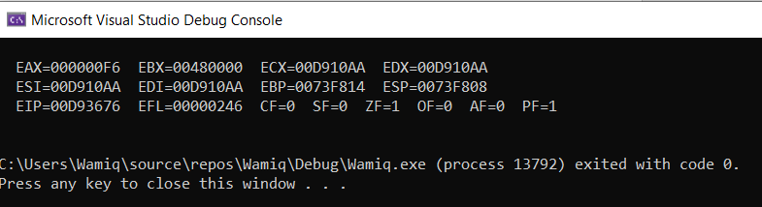

QUESTION 2:

TITLE My First Program (Test.asm)

INCLUDE Irvine32.inc

.data

val3 SDWORD -255

.code

main PROC

mov eax, 0

mov eax, val3

call DumpRegs

exit

main ENDP

END main

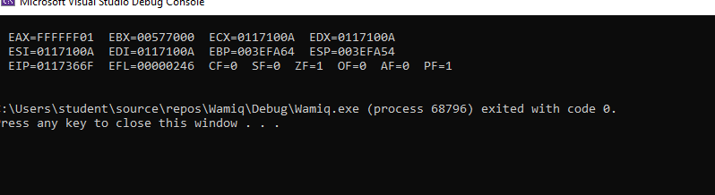

QUESTION 3:

TITLE My First Program (Test.asm)

INCLUDE Irvine32.inc

.data

Warray WORD 4,5,6

.code

main PROC

mov eax, 0

mov ax, Warray[0]

;mov ax, Warray[2]

;mov ax, Warray[4]

call DumpRegs

exit

main ENDP

END main

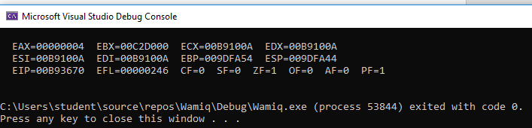

QUESTION 4:

TITLE My First Program (Test.asm)

INCLUDE Irvine32.inc

.data

String BYTE "Black" ,0

A word 12

B word 2

CC word 13

D word 8

E word 14

.code

main PROC

mov eax, 0

mov ebx, 0

mov ecx, 0

mov edx, 0

mov esi,0

mov ax, A

mov bx, B

mov cx, CC

mov dx, D

mov si, E

call DumpRegs

exit

main ENDP

END main

: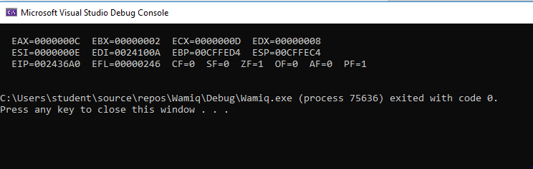

QUESTION 5:

TITLE My First Program (Test.asm)

INCLUDE Irvine32.inc

.data

x DWORD 10h

y DWORD 15h

w DWORD 20h

z DWORD 30h

.code

main PROC

mov eax, 0

mov ebx, 0

mov eax, x

add eax, y

mov ebx, x

sub ebx, y

sub eax, ebx

add eax, w

add eax, z

mov ebx, eax

call DumpRegs

exit

main ENDP

END main

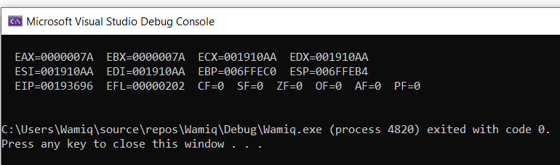

QUESTION 6:

TITLE My First Program (Test.asm)

INCLUDE Irvine32.inc

.data

x BYTE 16

y BYTE 21

w BYTE 32

z BYTE 48

.code

main PROC

mov eax, 0

mov ebx, 0

mov al, x

add al, y

mov bl, x

sub bl, y

sub al, bl

add al, w

add al, z

mov bl, al

call DumpRegs

exit

main ENDP

END main

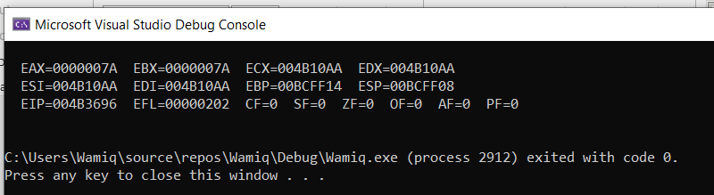

QUESTION 7:

TITLE My First Program (Test.asm)

INCLUDE Irvine32.inc

.data

Data1 WORD 8

Data2 WORD 15

Data3 WORD 20

.code

main PROC

mov eax, 0

mov ax, 20

add ax, Data1

add ax, Data2

add ax, Data2

call DumpRegs

exit

main ENDP

END main

